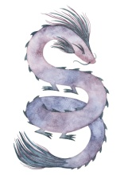

Spirit Dragon Healing Arts

Erin Benadik
LMT # 22050
Certified Amma Therapist
7409 SW Capitol Hwy #204
Portland, OR 97219
503-807-1256

In the last 72 hours:
- Have you had a fever of 100°F or above?
Yes No
- Do you now, or have you recently had, any respiratory or flu symptoms, cough, sore throat, loss of taste or smell or shortness of breath?
Yes No
- Have you been in contact with anyone in the last 14 days who has been diagnosed with COVID-19 or has coronavirus-type symptoms?
Yes No
Per the guidance provided by the Oregon Health Authority, I understand that I will be required to wear a mask for the duration of my treatment unless when on the massage table.
I understand that, because massage therapy work involves maintained touch and close physical proximity over an extended period of time, there may be an elevated risk of disease transmission, including COVID-19.
By signing this form, I acknowledge that I am aware of the risks involved and give consent to receive massage and bodywork from this practitioner.

Signature__________________________________ Date_____________________

